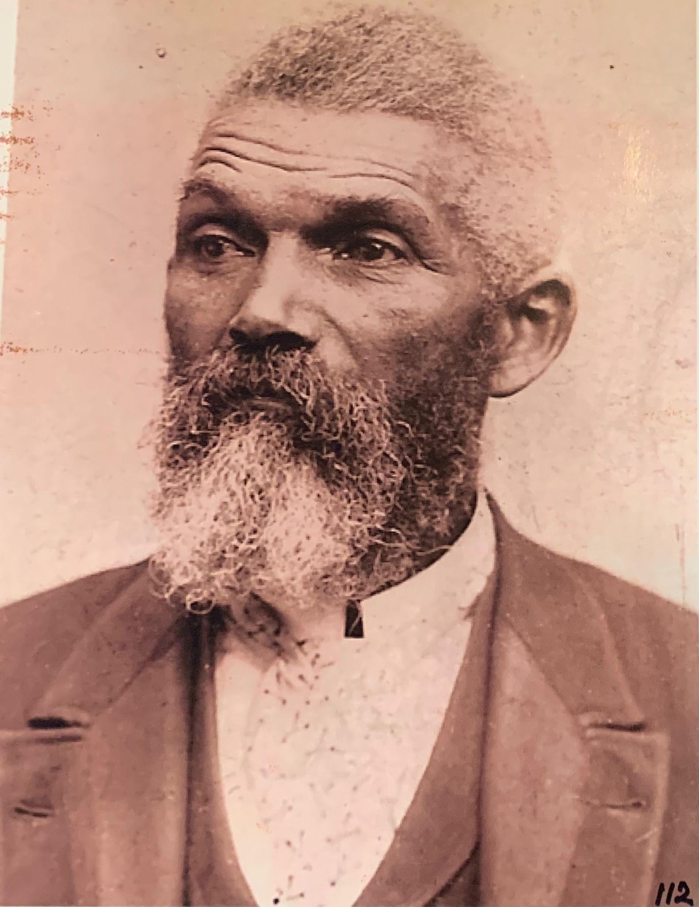

Ambrose Dallard. Photographer unknown.

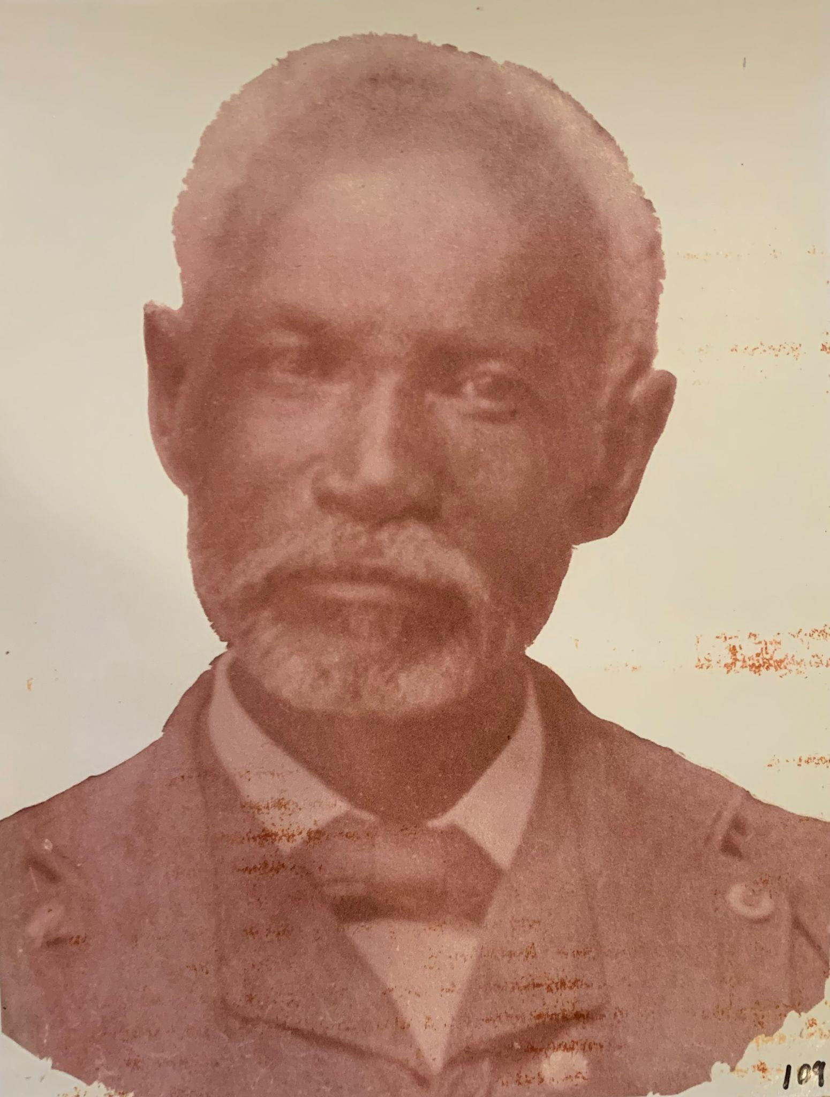

George A. Newman. Photographer unknown.

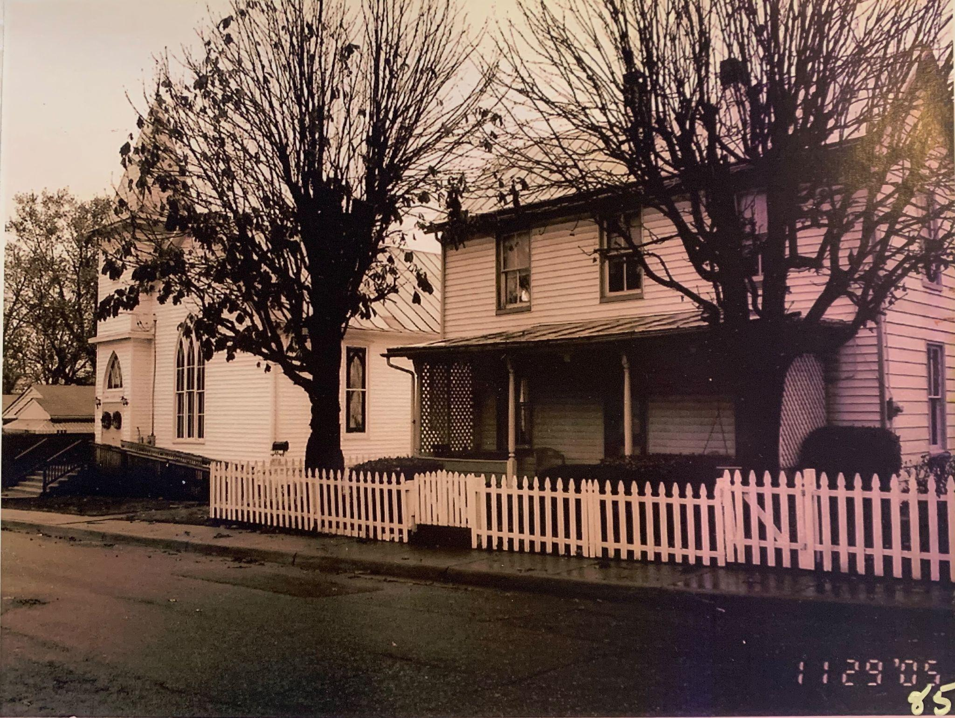

Dallard-Newman house, taken in 2005. Photographer unknown.